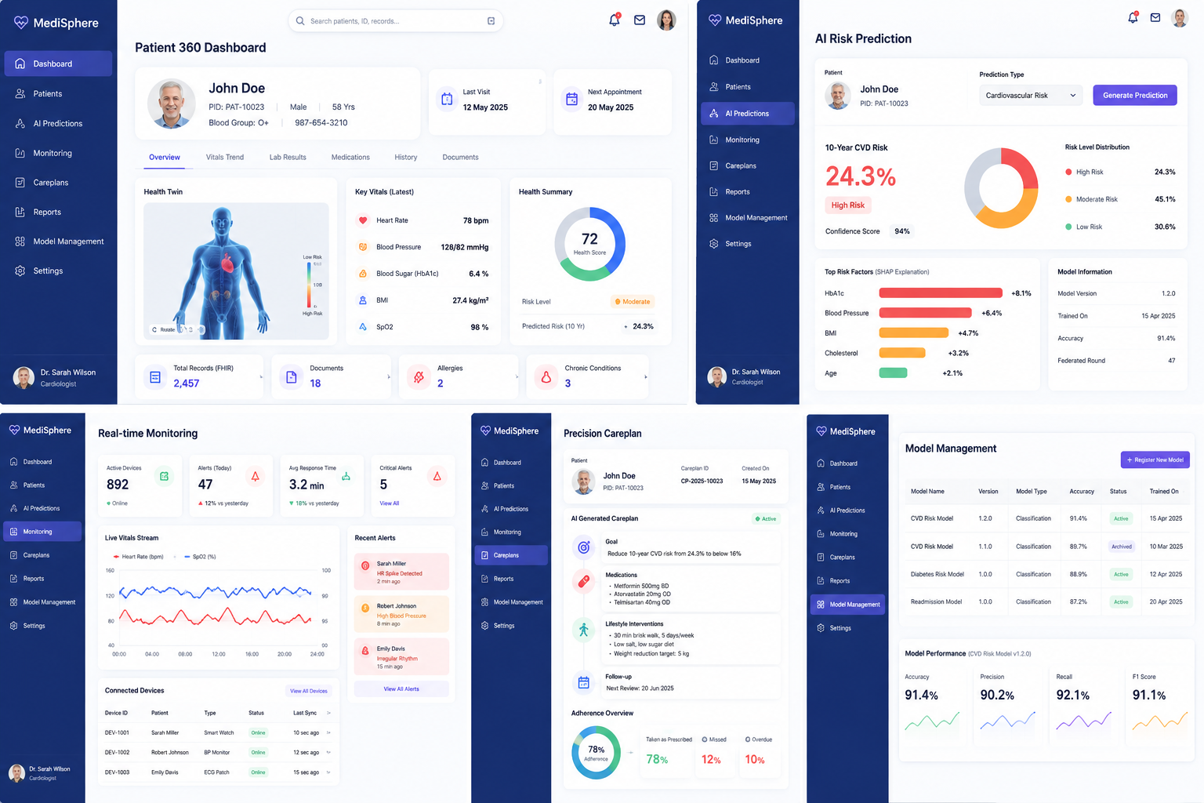

Milestone 2 Architecture
After Milestone 1 you already have
API Gateway
Authentication Service
Patient Service
FHIR Service
Health Twin Service
Consent Service
Kafka
MongoDB

Now add these services.
API Gateway
|
---------------------------------------------------
| | | | |
Patient Twin Service AI Service Model Service Explainability
Service Version Service
|
MongoDB

You only need 3 new microservices or use only 1 microservice.
- AI Prediction Service
- Explainability Service
- Model Management Service

Project Structure
medisphere

api-gateway

auth-service

patient-service

health-twin-service

consent-service

fhir-service

ai-prediction-service <-- NEW

explainability-service <-- NEW

model-service <-- NEW

AI Prediction Service
Responsible for
- Predicting CVD risk
- Predicting diabetes risk
- Returning prediction confidence
- Saving prediction history
Database Collection
risk_predictions

Document
{
"_id":"1",

"patientId":"PAT101",

"riskType":"CARDIO",

"riskPercentage":28.6,

"riskLevel":"HIGH",

"confidence":94,

"predictionDate":"2026-07-10",

"modelVersion":"1.0"
}

Folder Structure
ai-prediction-service

controller

PredictionController

service

PredictionService

repository

PredictionRepository

entity

RiskPrediction

dto

PredictionRequest

PredictionResponse

config

Swagger

Security

exception

util

REST APIs

Predict Cardiovascular Risk
POST

/api/prediction/cvd

Request
{
"patientId":"PAT101"
}

Response
{
"patientId":"PAT101",

"riskPercentage":27.4,

"riskLevel":"HIGH",

"confidence":94
}

Predict Diabetes Complication
POST

/api/prediction/diabetes

Response
{
"patientId":"PAT101",

"riskPercentage":18.6,

"riskLevel":"MEDIUM",

"confidence":91
}

Prediction History
GET

/api/prediction/history/{patientId}

Get Latest Prediction
GET

/api/prediction/latest/{patientId}

Delete Prediction
DELETE

/api/prediction/{id}

AI Prediction Logic
Use TensorFlow here
Age

Blood Pressure

Heart Rate

BMI

HbA1c

Cholesterol

Formula
Risk Score

=

Age

+

BP

+

BMI

+

Heart Rate

+

HbA1c

+

Cholesterol

Example
Age > 60

+15

BP >140

+20

BMI >30

+15

HbA1c >7

+20

Cholesterol >220

+20

Heart Rate >110

+10

Total
100

Risk
0-30

LOW

31-60

MEDIUM

61+

HIGH

Explainability Service
Purpose
Shows
"Why AI predicted High Risk"
This simulates SHAP.
Folder
controller

service

repository

entity

dto

Collection
explanations

Document
{
"patientId":"PAT101",

"risk":"HIGH",

"topFactors":[
"Blood Pressure",
"HbA1c",
"BMI"
]
}

APIs
Generate Explanation
POST

/api/explanation/{patientId}

Get Explanation
GET

/api/explanation/{patientId}

Response
{
"Risk":"HIGH",

"Factors":[

"Blood Pressure +20",

"HbA1c +18",

"BMI +14"

]
}

Model Management Service
Stores model information.
Collection
models

Document
{
"version":"1.0",

"accuracy":91.4,

"createdDate":"2026-07-12",

"status":"ACTIVE"
}

APIs
Add Model
POST

/api/model

All Models
GET

/api/model

Latest Model
GET

/api/model/latest

Activate Model
PUT

/api/model/{version}

Delete
DELETE

/api/model/{version}

MongoDB Collections
patients

health_twins

risk_predictions

models

explanations

API Flow
Doctor

↓

Gateway

↓

Prediction Service

↓

Health Twin Service

↓

Patient Data

↓

Prediction Logic

↓

Save Prediction

↓

Explainability Service

↓

Response

Frontend Screens

1. AI Risk Prediction Dashboard
Shows
Patient Name

Age

Current Risk

Confidence

Prediction Date

Button
Predict Risk

2. Prediction Result
Patient

John Doe

Risk

HIGH

Prediction

27%

Confidence

94%

3. SHAP Explanation Screen
Prediction Factors

Blood Pressure +20%

HbA1c +18%

BMI +12%

Heart Rate +5%

4. Model Version Screen
Version

Accuracy

Status

Created Date

Validation
According to the project document, Milestone 2 should demonstrate: model accuracy above 90%, federated round convergence, SHAP explanation validity, prediction calibration, bias audit across demographics, and clinical guideline compliance. For a student project, you can simulate these as validation checks and dashboard metrics rather than implementing full federated learning infrastructure.
Suggested validation endpoints:
GET /api/prediction/accuracy

GET /api/model/status

GET /api/explanation/validate

GET /api/prediction/calibration

GET /api/prediction/bias-audit

Recommended Milestone 2 Implementation Order
- Create ai-prediction-service.
- Build the RiskPrediction MongoDB collection and CRUD APIs.
- Implement rule-based CVD and diabetes risk scoring in Java.
- Create explainability-service to return the top contributing health factors.
- Create model-service for version and accuracy management.
- Connect all three services through the API Gateway.
- Build Angular pages for AI prediction, explanation, and model management.
- Test all APIs using Postman and verify end-to-end flow from patient data to prediction results.

